MODEL IRRIGATION DISTRICT 2025 ANNUAL WATER QUALITY DATA REPORT

Listed below are the drinking water contaminants that we detected during the 2025 calendar year. The presence of any contaminant in the water does not necessarily indicate that the water poses a health risk. Unless otherwise noted, the data presented in this table is from testing done January 1-December 31, 2025. The state requires us to monitor certain contaminants less than once per year because the concentrations of these contaminants are not expected to vary significantly from year to year.

Parameter | Exceed MCL | Exceed MCLG | Level Detected | Likely Source of Contamination
Microbiology  144 samples were taken during the year at all well sites & sample stations.  Total Coliform Bacteria Fecal Coliform and E. Coli | NO NO | NO NO | All tests were satisfactory. | Naturally present in the environment, and from industrial or domestic wastewater discharges, mining or farming and livestock productions.
Inorganic Chemicals  As required. IOCs per well site Herbicides, Pesticides  Nitrate All Satisfactory, tested annually. | NO NO  NO | NO NO  NO | All tests below MCL. | Runoff from fertilizer use; leaching from septic tanks, sewage; erosion of natural deposits.
Synthetic Organic Compounds  As required Tested for SOC’s per well site | NO | NO | All tests N/D within the sensitivity of the instrument. | By product of industrial processes & petroleum production, leaking petroleum storage tanks, cleaning.
Volatile Organic Compounds  As required All wells tested for VOC’s. | NO | NO | All tests N/D. | Solvent spills/discharges into storm drains or sewers.
Lead and Copper  19 samples taken | NO | NO | In Compliance with state and federal guidelines. | Leaching from metal water pipes and fittings.
PFAS and PFOA Quarterly | NO | NO | In compliance with state and federal guidelines. | Industrial

TERMS AND ABBREVIATIONS
- ND: non detectable at testing limit
- pCi/l: picocuries per liter

  - 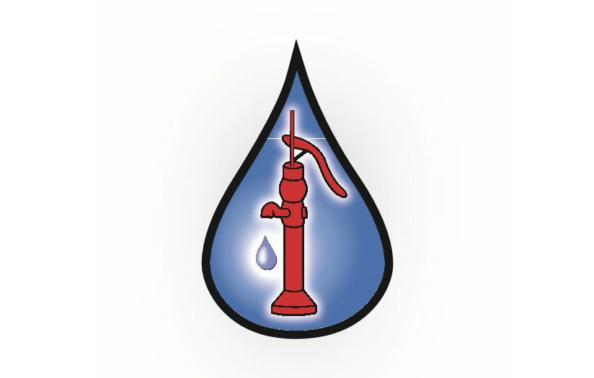Maximum Contaminant Level (MCL): the highest level of a contaminant that is allowed in drinking water. MCLs are set as close to the MCLGs as feasible using the best available treatment technology.
  - Maximum Contaminant Level Goal (MCLG): the level of a contaminant in drinking water below which there is no known or expected risk to health. MCLGs allow for a margin of safety.
  - Action Level (AL): the concentration of a contaminant which, when exceeded, triggers treatment or other requirements which a water system must follow.
  - Turbidity: a single day or series of consecutive days, when one or more turbidity measurement each day exceeds 5 NTU (nephelometric turbidity unit). Indicates possible microbiological excess.

