2026 NEWSLETTER

MISSION STATEMENT: Model Irrigation believes we have one of the best drinking water sources available. We are constantly striving to keep it supplied to you, our customer, in a pristine form at an economical rate.

DISTRICT PHILOSPOHY: As a public water system, representing the people in our area, at Model Irrigation we make it our duty to provide the best service, while conforming to local, state, and federal regulations.

This year Model Irrigation is focused on completing phase 2 of our 18” Transmission Main Project. The project consists of 3 Phases that will hydraulicly move large amounts of water from the north end of the district to the south end. Phase 2 will begin this summer at 32nd & Pines, and continue east to 32nd & Clinton Rd. Since last summer, Model Irrigation has completed a pump upgrade at our booster station on Bowdish & 16th. There have been smaller residential developments on Pierce & 27th and Pierce and 35th. These developments bring new infrastructure to these areas with improved fire flow and water main upgrades.

As notified in 2025, Model Irrigation has completed our rate study, and excess water charges have gone into effect. The last time Model Irrigation changed water rates was in 2018. Basic water is collected through the Spokane County Treasure and in 2027 the rate will increase to an equivalent of $2.98 per month. We understand the impact rate changes can have, but it is important that we stay current with the times as energy costs have changed over the years as well. The new rate structure will be available on our website.

2026 EXCESS RATES begin after 6,000 cubic feet (cf) of water that is used over 12 months. You are charged .32 cents per hundred cf for the first 25,000 cf of excess use and .37 cents per hundred cf for excess use over 25,000 cf.
Note: 100 cf = 748 gallons. (1,000 cf = 7,481 gallons of water). Meters are read only once a year starting on October 1st.

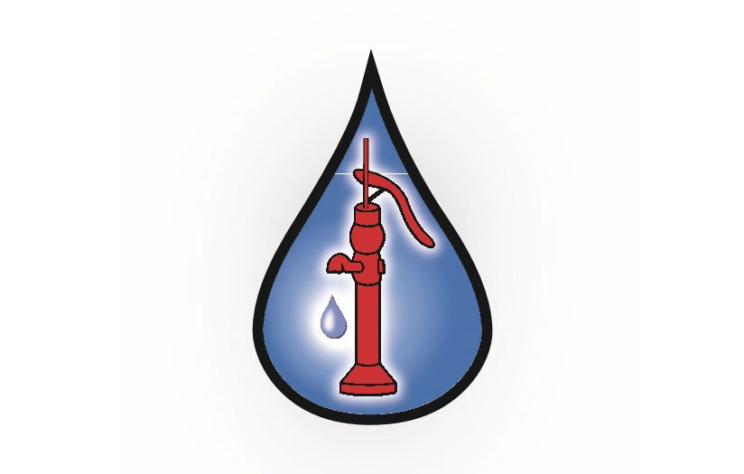In 2025, the district performed 144 drinking water contaminant tests. Water quality details are included on the opposite page. Also, included is information about how your drinking water meets and/or exceeds the Environmental Protection Agency (EPA) and state standards. We are committed to providing you with this information because informed customers are our best allies. PFOS AND PFOA are non-detect and below state action levels in all our wells currently. We will continue testing per the state and federal laws.
ALL SPRINKLER SYSTEMS require backflow protection to protect you and our water mains. These devices need to be tested annually by a licensed Backflow Assembly Tester (BAT). Please contact our office to get information on getting your backflow device tested.

Household leaks can be checked by looking at your water meter while all fixtures and faucets are closed. If your meter appears to be rotating, chances are you have a leak in this situation.
These leaks cost money and should be addressed before they add up. If you need help identifying a leak, please contact our office.

Our Water Use Efficiency report for 2025 will be on our website, along with the UCRM5 data summary.

Please notify our office of any changes or updates on your billing information. Model Irrigation only accepts checks, cash, or bill pay through your bank account. Any after-hours payment can be dropped in our secure drop box attached to our office just to the left of our front door.

Model Irrigation has a recent change of staff and would like to introduce Ryan Neal as the new District Manager. Ryan has worked in this industry for 16 years and has been with Model Irrigation for the last 10 years. We would also like to introduce our newest Maintenance Operator, Shawn Poirier. Our current staff is very excited for Model Irrigations’ future operations and quality service to the public!

Board Meetings are held on the 4th Tuesday of every month at 9:00am at 1424 S. Pierce Rd.
Meetings are subject to change, contact us to verify the time and date if you would like to attend. Your participation is welcome!

Model Irrigation is available 24 HOURS A DAY at 509-926-5759. If you have an emergency after hours our on-call staff will be available to help. Operation hours are Monday-Friday 7:00am to 3:30pm. Visit us online at modelirrigation.org. EPA's hotline number 1-800-426-4791.

BOARD OF DIRECTORS:
Ryan Heaton - President Jessica Bain - Director
Toni McComb-Keck - Director

MODEL IRRIGATION STAFF:
Ryan Neal - Superintendent
Justin Bevans - Assistant Superintendent Shawn Poirier - Maintenance Operator Karen Parker - District Secretary

